GORDON SETTER BREED COUNCIL
Health Report Form
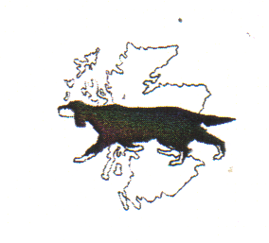

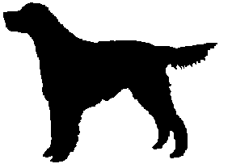

I would like to add the following health condition(s) to the Gordon Setter Breed Council health database.
Personal details will remain confidential. Any results/statistics will be anonymised for publication ( breed health reports published in newsletters and club websites)

Dogs Kennel Club Name Pet Name
Breeder DOB
Sire Kennel Club Name
Dam Kennel Club Name
Veterinary Practice

Condition | Tick | Condition | Tick
Hip dysplasia |  | Lipoma
Osteochondritis Dissecans [OCD] |  | Skin cysts
Osteoarthritis |  | Urinary incontinence
PRA [rcd-4] |  | Kidney Failure
PRA [unknown] |  | Epilepsy
Vaccine reaction |  | Seizures
Juvenile Pyoderma |  | Otitis (externa/media)
Canine Symmetric lupoid onchodystrophy |  | Gastric Dilation Volvulus
Hypothyroidism |  | Diabetes mellitus
Lymphoma |  | Dilated Cardiomyopathy
Melanoma (Skin/oral) |  | Heart murmur
Mammary tumour |  | Irregular Heart Rhythm
Osteosarcoma |  | Allergies (Food/Environment)
Stomach tumour |  | Behavioural problem
Bladder tumour |  | Other

Please give further details overleaf

Please give any information on conditions not listed or further information on the condition(s) ticked. This may include age of diagnosis,lab reports,vaccine make and anything you think may be useful.

Owner name Sign Date

Please return to ; Kathryne Wrigley RVN ,Gordon Setter Health Co Ordinator,58 Station Road,Hugglescote,Coalville,Leicestershire,LE67 2GB
kathrynewrigley@hotmail.co.uk

Thankyou for taking the time to fill in this report,it is much appreciated.

